### Scoring 1.01 – a Crossroads

I trust you all know that Compass has been evolving for over 45 years as the life’s work of Bob Fearn, a Kiwi who has lived in Seattle since the turn of the century. Bob is one of the game’s best-kept secrets and possibly knows more of what’s happening in the game than anyone else. He must have written literally millions of lines of code for the pure love of a game he hadn’t actually played in quarter of a century. Bob and Marie had two-three months in NZ recently and I got to play a game with him at Cambridge. It was astounding to hear him comment that it was the first time he’d had to physically use a Bridgemate when I made him sit South. We are very fortunate to have such a talented and generous person involved in the NZ bridge scene

As will be widely known, big changes are upon us with Bob’s having re-written CompassV6 in a new language - Visual Basic .NET. This is an awkward time to be introducing you to something that may be history within the next year as VB.Net gets rolled out to all clubs. We’ll be seeing how similar much of today’s content will look in the new screens

### Scoring 1.01 – Room Set-Up

There are many factors to consider when setting up a session – best done in tandem with another person (director?) to make the best choice

Virtues of SAM vs Detailed Setup – toggle between

* Three simple questions to answer to filter for “bomb-proof” movements
* Avoids pairs having to sit out more than once
* Offers alternatives to movements that have pairs meeting more than once for a “Revenge Round”
* Avoids need to truncate sessions
* Advises best position for Phantom and Stationary Pairs
* On-screen summary and easy access to full documentation of room set-up

All that is needed is the ability to read and follow instructions PLUS an awareness of how these relate to players in stationary positions (Melanie). Safest to have MI’s sitting NS at T2-T5 unless otherwise specified for, say, a Howell but if required you can nominate *any* pair as stationary in the Adjustments tab of Compassmate once all names are entered. Instructions will be printed on Personal Guide Cards – example below

Avoid slow players sitting at a table that shares boards

**Don’t be scared of “funny movements” .. your players will get used to them and even come to prefer them**

Demo SAM and Detailed Setup

Advise all clubs will be migrating to Compass.VBNet sooner or later. Give a quick tour of SAM – no difference

A Personal Guide Card with supplementary stationary pair

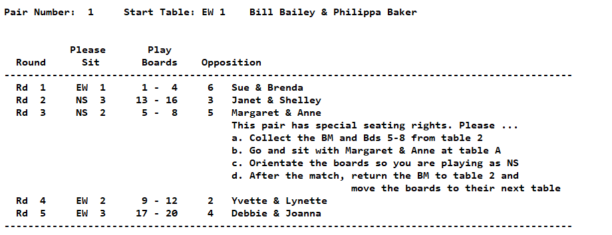

### Scoring 1.01 – Architecture

As this venue uses Bridgemates what follows will be from that perspective although - of the 45 Compass clubs listed on mycompasss.com > Compass > Clubs, 19 use BM and 26 are now using BridgePal. Owing to their lack of support at every level Bob is ditching BridgeTab

There are three elements to an electronic scoring system: one is the hardware – server and Table Top Units (TTU’s), another is the software that collates the data, and the third is the interface between them – Compassmate (a conflation of Compass and Bridgemate). When Compassmate is first opened it loads a Plan of Attack – a matrix that specifies which NS meets which EW at which table with which boards for every round. This can – and *should* – be eyeballed the first time you see it. It’s what’s going to happen and if anything looks fishy then you need to back off right there and then. Compassmate reads the BWS file – a Microsoft Access Database which builds as it records the results from the server as they are transmitted from the devices

Once the server is started it will keep filling in this matrix quite happily all by itself. You can back right out of Compass and even reboot the computer – the server will continue to gather data from the TTU’s – under battery power if necessary (you should check the battery levels in BCS occasionally). When you come back in via View Session Results Compass will automatically open the active session. Note the warning – “Do You Really Want to Exit Compass” if you try to close a session while the server is still running – an excellent way to alert you to this situation which can happen in the “normal” course of events .. the server is still expecting a result/s to come in (slow table – or did not record a DNP on the last board). Upon **Open/Return to Compassmate** the Scores Entry Status panel will populate with any data gathered while you’ve been away. Only expected data still to be received will show by default though it is possible to display all data in the matrix

Think of Compassmate as an island upon which there is a trove of data. There is a drawbridge connecting this island (Compassmate) to Compass (the mainland). Lower the drawbridge with **Open/Return to Compassmate** from the **Results** screen; raise the drawbridge with **View This Sessions Results** from the **Compassmate** screen. Compass imports results from Compassmate only while the drawbridge is lowered and Read Scores is ticked. NB – screen jumping around can be stopped once all names are in by unticking Read Names

Demo flipping between the two

Demo in VB.Net – same thing

Kevin Turner’s schematic [System Architecture.pdf](https://www.dropbox.com/scl/fi/fco4h1qv0sthyeoc88f15/System-architecture.pdf?rlkey=igcpcfccd5gn3a10ewgj8g1w1&st=pqnrwmdd&dl=0) in Compassmate/Shared Documentation

### Scoring 1.01 – Basic Procedure

So .. you’ve chosen the movement and find yourself in Compassmate. Using Bridgemate you need to tick both Start Reading boxes - with BridgePal they’re ticked already. Then Start Bridge Control .. do NOT click this whenever it is green – means it is already going (???) Seek help

After that when all runs normally there’s nothing to do until all results are in. Often the Start Bridge Control button is red (stays green until all table-top units have idled out). The Scores Entry Status panel in Compassmate should be empty. If anything is showing there then it’s still waiting for that result. Normally it’s a slow table but sometimes it may be that someone has forgotten to send in their last result and gone home. You have some detective work to do before raising the drawbridge to view the session result in Compass

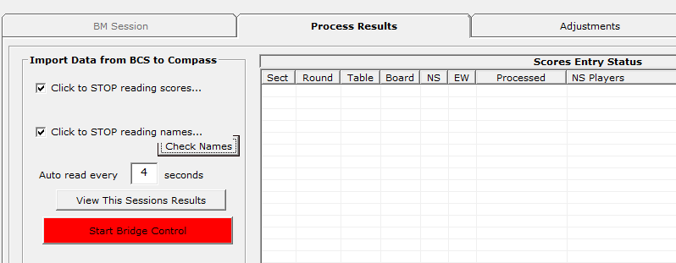

Raising the drawbridge (**View This Sessions Results**) takes you back to the Results screen. Think of this Results screen as a hub to which you must return after doing stuff like editing Names or Scores or producing Ladders. This is different in VB.Net where you can move between tabs. It is the only path leading back to the sidebar menu. Every club should have detailed procedure on what needs doing at the end of a session. Cambridge’s and Te Awamutu’s ones – warts and all - are attached to the article on this topic on the WB site.

In summary these things usually need doing:

* Check all pairs have played the expected number of boards – scan results column or look for any TBA advice at the bottom of the screen
* Check neither Names nor Scores buttons are red – if they are then you need to take action*
* Handicaps are applied automatically if a List has been defined in the Calendar – there is an Option to change the Handicap List
* Print both Raw and Handicap results .. if they’ll fit, both will appear on a single A4 when you print Raw
* Publish the results to your club’s website and check website .. got the correct hands?
* Update and post the Competition Ladder
* Email results to players – if you wish
* (Post to Compa$$ - first checking for correct Director)